***Pp bottles***

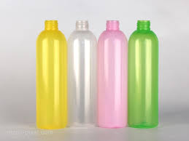***PP Bottles (Polypropylene Bottles) are another popular type of plastic bottle used for packaging a wide variety of products.***

* ***Small PP Bottles (30ml to 100ml)***
* **Price Range:**
* **PKR 7 to PKR 15 per bottle (individual pricing).**
* **Bulk pricing (for larger orders of 1000+ units):**
* **Around PKR 5 to PKR 10 per bottle.**
* ***Medium-Sized PP Bottles (100ml to 1L)***
* **Price Range**:
* **PKR 15 to PKR 35 per bottle (individual pricing).**
* **Bulk pricing: Can range from PKR 10 to PKR 20**
* **Per bottle for larger orders.**
* ***Large PP Bottles (1L to 5L)***
* **Price Range**:
* **PKR 50 to PKR 150** per bottle (individual pricing).
* **Bulk pricing**: **PKR 35 to PKR 80** per bottle (for bulk purchases of 1000+ units).

***Customized PP Bottles***

* **Price Range:**
* **PKR 25 to PKR 80 per bottle (depending on complexity and quantity).**